Dmytro Morykit’s ‘Metropolis LIVE’ at Green Man 2016
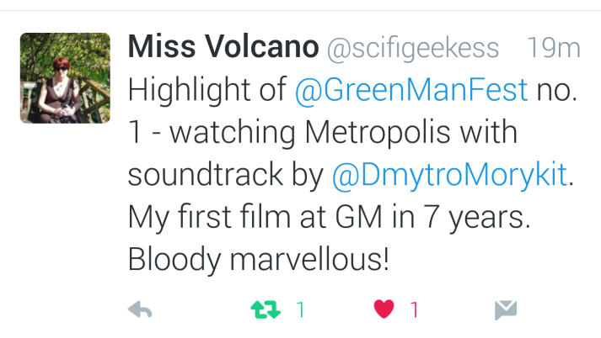
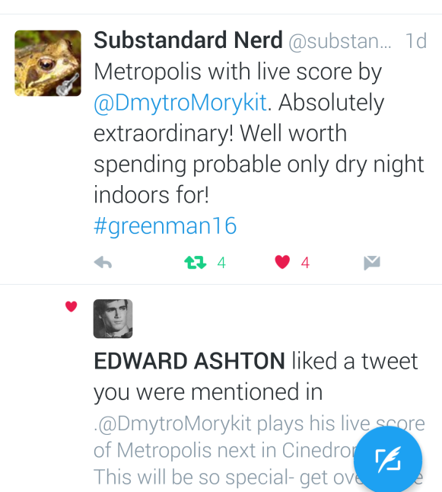

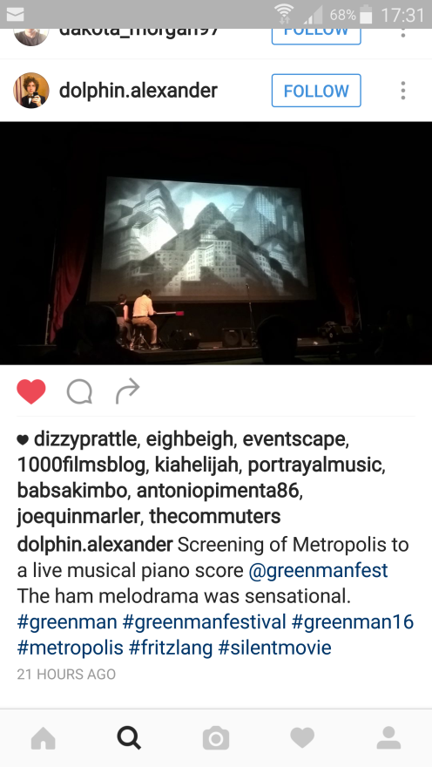
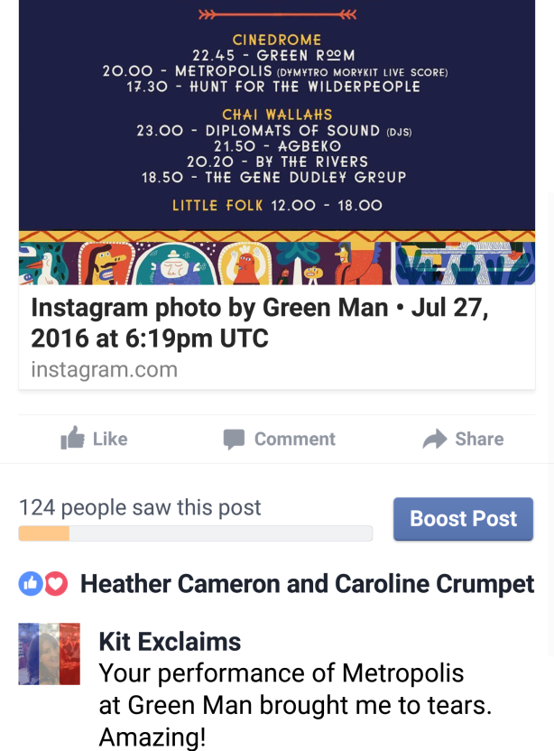

http://www.tuppencemagazine.co.uk/green-man-2016-highlights/
Metropolis’ with a live score by Dmytro Morykit which was a special experience; it was a taster for the uniqueness Green Man had to offer.
http://www.buzzmag.co.uk/uncategorized/green-man-festival-2016-live-review/
The screening of Metropolis, which was accompanied by a live piano score by Dmytro Morykit, was an enthralling experience to behold and was the perfect mood-setter for a long night of music and DJ sets.

